Course Submission Form
Use this form to submit a new course to the Registrar's Office. By using this form, you agree that this change has already been approved by the Curriculum Committee for your College or School.
*Please submit the completed form in an ITS Help Desk ticket using the category: Course Scheduling/Room Change Requests.
* Required
Name* _______________________
Change Type * (please highlight)
New Course
New Special Topic (if shell already exists)
Course Number Change
Title Change (please send by email)
Course Description Change (please send by email if no other changes)
Subject Code *

Course Number (i.e. 1103) *

Previous Course Number
(if submitting a course number change)

Effective Term * (please highlight)
Fall
Winter
Spring
Summer
Course Title *

Long Course Title
(if longer than 30 characters)
CIP Code *
Please use the IPEDS Search Tool to select the most relevant code for this course. The course CIP code does not necessarily have to equal the major/degree CIP code. https://nces.ed.gov/ipeds/cipcode/search.aspx?y=56

Number of Credits * (please highlight)
0
1
2
3
4
5
6
Variable Credit?
No
Other:
Level * (please highlight)
01 Undergraduate
02 Graduate
03 Doctorate
04 Non-Credit
Grading Mode * (please highlight)
Standard (A-F)
Pass/Fail
Satisfactory/Unsatisfactory
Schedule Type * (please highlight)
Classroom
Hybrid
Laboratory
Online
Other/No Room Required

Instructional Method *
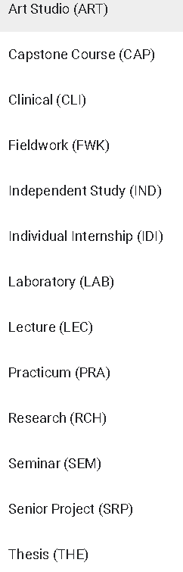
Corequisite(s)

Fee(s)

Degree Attributes *
Please click here for a list of valid course attributes: https://goo.gl/cNqMKl -- If none, write "none"

Course Description *
Restrictions
Who may or may not take this course? You may restrict by level, major, school, etc.

Prerequisites *

